Succession Planning

# Introduction

Nowadays, the development of business and marketing has led to an increasing number of large-scale companies. The difficulty of human resource management is growing with the size of company simultaneously. The more employees a company has, the harder it is to handle employee distribution and turnover affairs.

The goal of this article is to access rapid recognition of the employee’s personal features; then utilize the information to implement dynamic succession planning.

# Analysis

## Dataset description

The dataset is acquired from Kaggle website. It contains the employee information of a company in San Francisco, including employee ID, date of birth, date of hire, sex, department, position, pay rate and so on. The dataset documents the information of a total of 357 employee from 2006 to 2016.

## Software used

The report used R to preprocess the data, rejecting entries containing NA (missing value); then used Tableau 10.5 to visualize the data.

## Approaches

We first need to figure out the composition of the company. The company consists of 6 different departments, including Admin Office, Executive Office, IT/IS, Production, Sales and Software Engineering. And each department contains different positions. From Table 1 below, we get the number of employee at different position in different departments. As it is a typical high-tech industrial company, we could see that the IT/IS department and the production department hire the most employees.

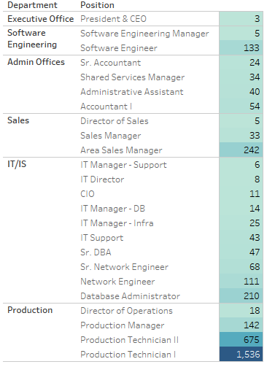

Table 1: Employee Number by Departments and Position

We then analyze the age distribution of the employees. From Figure 1 below, we can see that the majority of the employees are aged between 28 to 38. Furthermore, employees at higher position, for instance, department director and manager, tend to be older; while those at lower position tend to be younger.

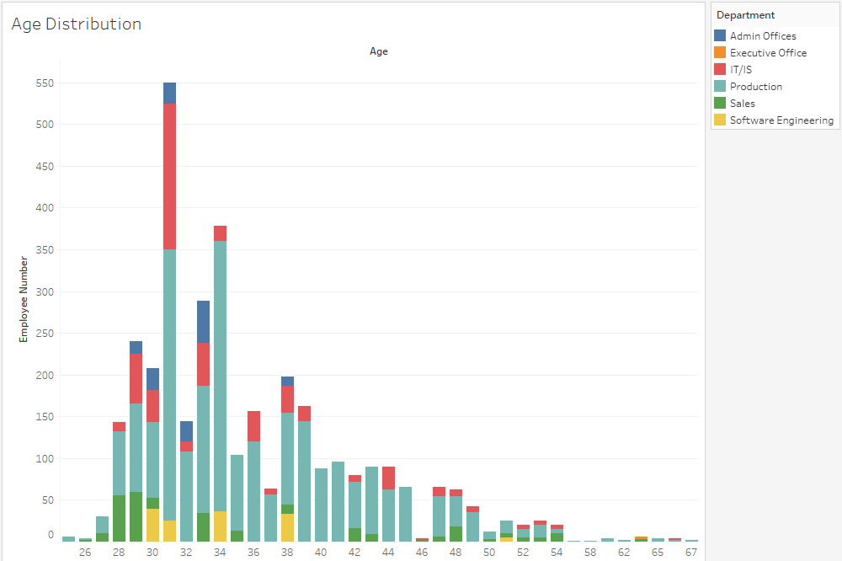

Figure 1: Age Distribution

To implement dynamic succession planning, we need to create a parameter called “retirement age” and two calculated fields called “retirement year” and “time left before retirement” respectively. The “retirement age” is set to be an integer with a current value of 60, within the range from 55 to 70. “Time left before retirement” is calculated as [retirement age]-[Age]; while the “retirement year” is calculated as YEAR( TODAY() )+[Time left before retirement]. We then could monitor the remaining working time of each individual employee.

In figure 2 below, by choosing different department in the filter, we can get retirement information of each employee at different position in a certain department.

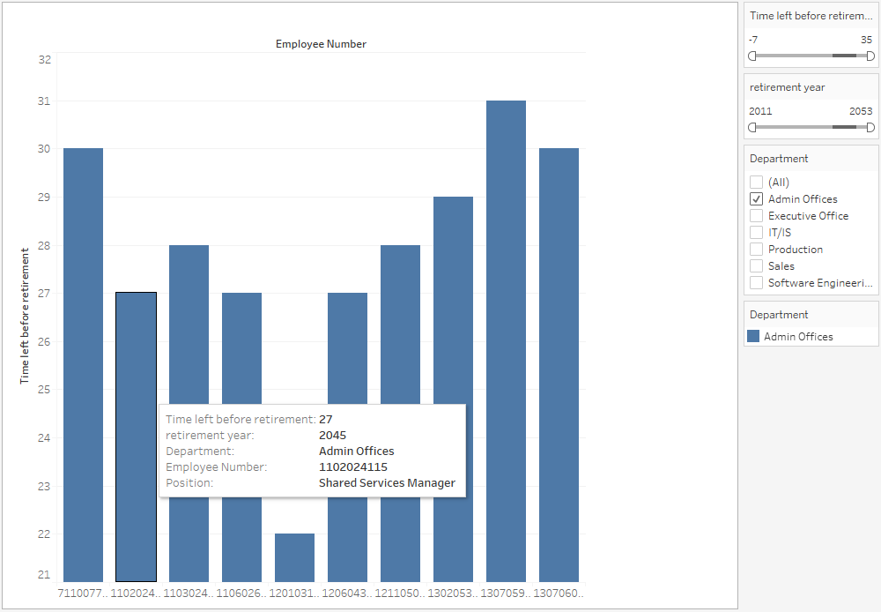

Figure 2: Succession Planning by department

By narrowing the range of the time left before retirement in the filter or changing the retirement year to the coming few years, as in figure 3 below, we could get to know those employees who are to retire soon and in urgent need of successor. As we know, promoting a manager to department director could mean long-time training and much work handover. There is no way to get over in a short time. Thus, it would be much better if we were able to implement succession planning in advance.

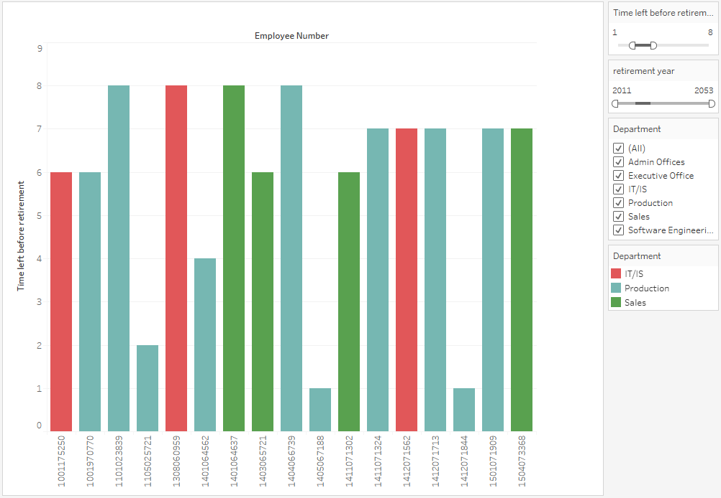

Figure 3: Succession Planning by Time Left Before Retirement

Apart from succession planning, we can also get other information from the dataset and come up with some suggestions for human resource management. In figure 4 below, we can see that internet search and social network have now become a great source of enrollment in recent years. This means companies could step up efforts on online promotion apart from traditional offline job fairs in times of recruitment.

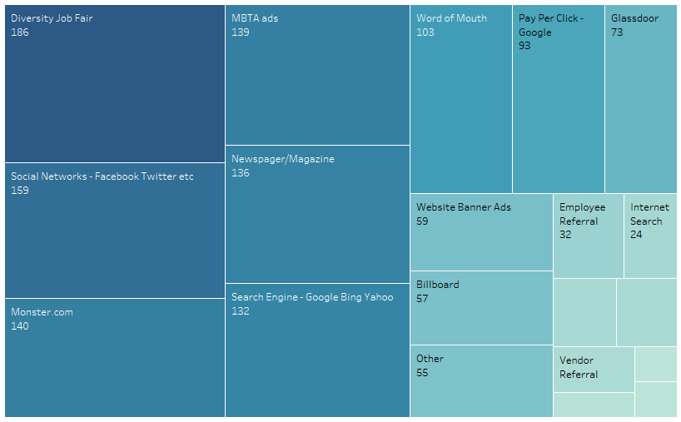

Figure 4: Source of Employment

# Conclusion

Tableau is a very useful tool in dealing with human resource management problems. Companies can turn to Tableau to manage employee information visually and implement succession planning dynamically. Many other data-multifarious and time-consuming problems could also be solved with the help of Tableau. The utilization of Tableau in companies nowadays is worth popularization.